**Lab Assignment 2**

STUDENT ID: 301344590

STUDENT NAME: Ahmed Mohammed

**Home Screen**

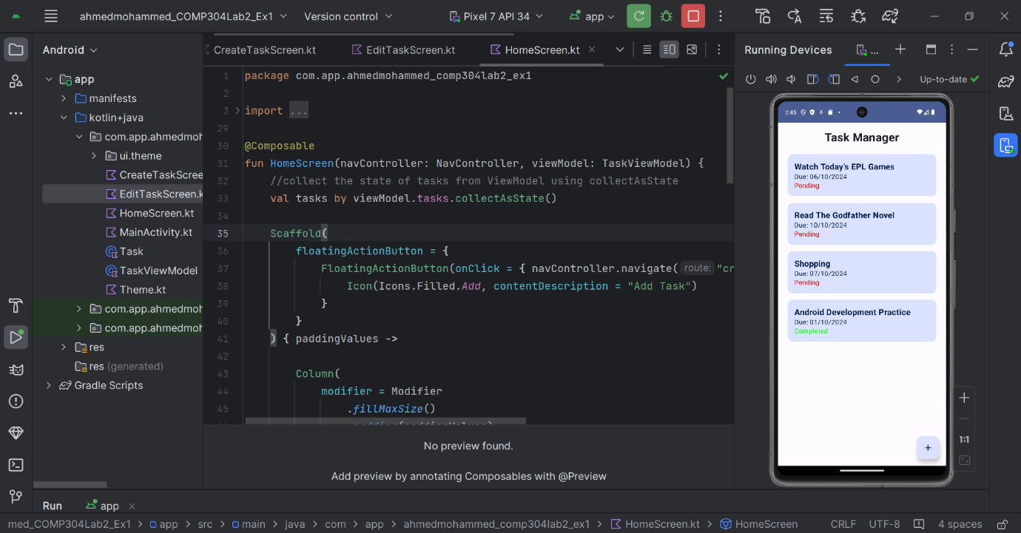

**Add Task Screen**

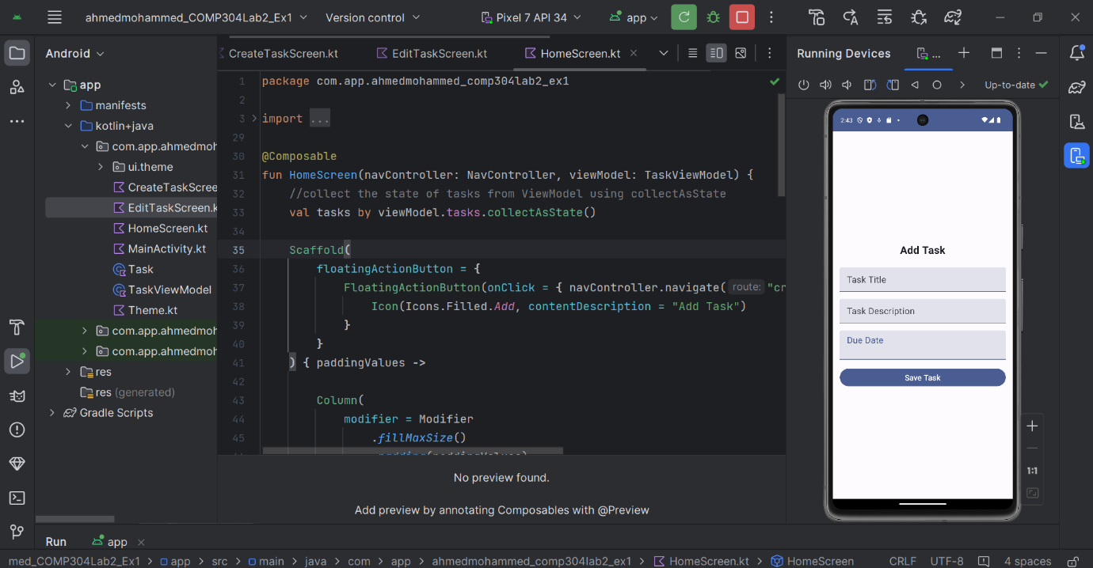

**Edit Task Screen**

